‘

Norwalk Talks Housing

Summary of Public Listening Sessions

Overview
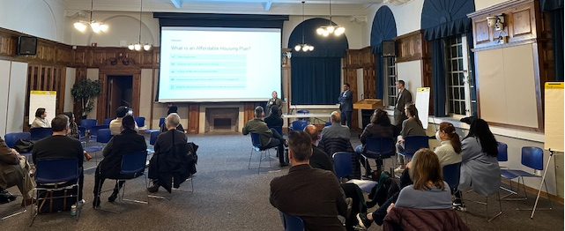
The City of Norwalk, in partnership with a consultant team, organized two public listening sessions to gather input on the current and future housing needs. The first listening session was held in-person on November 16th. The second session was held online via Zoom on November 30th. Attendees included Norwalk residents, city officials, not-for-profit organizations, and members of the economic development community. During the engagement sessions, residents frequently noted the high cost of the current housing stock and a strong desire for a new housing stock that can meet the needs of current and future residents. They expressed a desire to make the housing stock more diverse, affordable, and inclusive of services. Session participants also shared a willingness to be a model for housing reform and opportunity in the State. Below is a summary of the questions asked at the public listening sessions and the input received.

Summary

Does the current housing stock meet the needs of current residents?

Input provided at the sessions consistently indicated that the current housing stock does not meet the needs of residents. Many residents indicated that Norwalk has become unaffordable, including current homeowners who shared that they would not be able to buy a home in the City today. Overall, residents noted that Norwalk is becoming a less accessible community to live in.

Who are we trying to house?

Participants indicated that young adults, students, and first-time home buyers struggle to find housing in Norwalk that meet their needs and/or income level. Many residents expressed concerns that their children would not be able to afford a home in Norwalk later in life. In addition, residents expressed a need for housing that accommodates large family units and the local workforce/public servants. Many residents stressed the importance of being able to live and work in Norwalk in order to help with shorter commute times and to foster economic development in the City. Finally, it was noted that the aging population, individuals with mental and physical disabilities, immigrants, and the homeless population also lacked housing.

What type of housing should be built to serve housing needs?

Many residents expressed disenchantment by the two ends of housing types currently being developed, specifically single-family housing units and high-end multi-unit rental apartment complexes. Therefore, session attendees expressed a need to increase the housing supply and build a variety of housing types that meet different income levels. The following housing types were discussed:

Duplexes and Townhouses: Residents expressed a desire for duplexes and townhouses. Norwalk residents felt that duplexes could be well-designed and promote a sense of community while at the same time fit into available parcels of land especially when built densely.

Unit with 2 Plus Bedrooms: Residents expressed a need for units designed with families in mind that included two or more bedrooms.

Accessory Dwelling Units: Norwalk residents supported the inclusion of accessory dwelling units (ADUs) to expand housing options where there are single family homes.

Small/Micro-Units: Some residents were receptive to the idea of smaller housing units or micro-units to support housing availability for young people and students.

Supportive and Transitional Housing: Participants noted a need for both transitional and supportive housing, including housing with wrap-around services and units designed to accommodate people with special needs.

What are the obstacles to addressing the housing need?

A common issue raised by residents is the stigma around affordable housing. According to participants there is a vocal minority who are resistant to proposals for zoning reform, density, and affordable housing developments. Participants expressed a need to change the vocabulary and educate citizens on the benefits of affordable housing. Many residents acknowledged the need to monitor planning and zoning efforts to ensure that they align with housing needs. In addition, participants noted a desire to partner with developers to build the needed housing stock and incorporate creative options. Finally, participants expressed that housing developments need to be linked with improvements to the public transit system and transit accessibility.

What are some solutions or opportunities?

Residents focused on the need to create homeownership opportunities, especially for first- time homebuyers. They proposed solutions that include multiple housing types at a range of price points for purchasers, including single-family homes and condominiums. In addition, participants suggested that the City provide guidance on home buyer programs, such as financial counseling and downpayment programs. In addition, session attendees indicated that some of the housing stock is old and needs rehabilitation. They suggested programs to assist not only new home buyers, but existing homeowners, with improvements to their housing condition. Rehabilitation programs and building code enforcement should be utilized to address building condition issues in rental units/developments. In addition, participants suggested that the City take steps to support the development of Accessory Dwelling Units (ADUs) by relaxing restrictions, targeting outreach to current homeowners, and providing incentives for current homeowners to build ADUs. Finally, a few participants suggested clustering tiny homes on single-family lots.

Are there sites that you can imagine as housing?

Residents identified some specific sites/areas that could be future locations for housing. Corporate offices, vacant commercial, City-owned lots, industrial sites, and religious institution property were suggested as possible locations to be adaptively reused for housing. There was an acknowledgement that housing development at these sites may be cost prohibitive, but still worth consideration.

