Norwalk Transportation Master Plan

Updates to Norwalk Tomorrow project page

December 5, 2022

Give Us Your Input
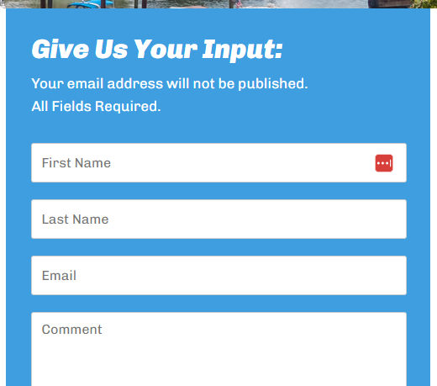
- Where are these comments going? Does the city have a record of comments received?

Quick Links
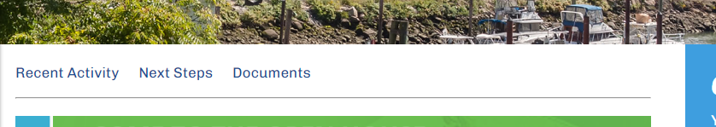

- Add new link: Draft Transportation Master Plan
  - Link to: https://arcg.is/CXHzy

RECENT ACTIVITY
- Add new bullets:
- A list of strategies was developed as a toolbox approach to addressing plan needs in the context of the six plan goals.
- A series of early action concept plans have been developed as part of the plan. These concepts illustrate the types of improvements that may address current funding opportunities, near-term solutions to known issues, and strategic or long-term projects to address plan goals.
- The complete Draft Transportation Master Plan is published online for public review and comment.
- Remove the survey link:
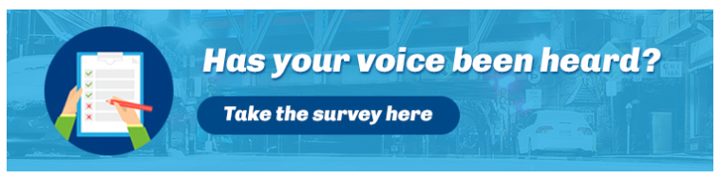

Next Steps
- Review and incorporate public feedback on the Draft Transportation Master Plan.

Documents

- Norwalk TMP Goals and Metrics (keep as-is)
- Norwalk TMP Needs Assessment Draft (keep as-is)
- Draft Transportation Master Plan (new bullet with hyperlink)

